Project Design Phase-II
Data Flow Diagram & User Stories

Date | 13 October 2026
Team ID | SWTID-2026-4152
Project Name | AI WeatherWise API
Maximum Marks | 4 Marks

Data Flow Diagrams:
A Data Flow Diagram (DFD) is a traditional visual representation of the information flows within a system. A neat and clear DFD can depict the right amount of the system requirement graphically. It shows how data enters and leaves the system, what changes the information, and where data is stored.
Example: DFD Level 0 (Industry Standard)
Example: (Simplified)
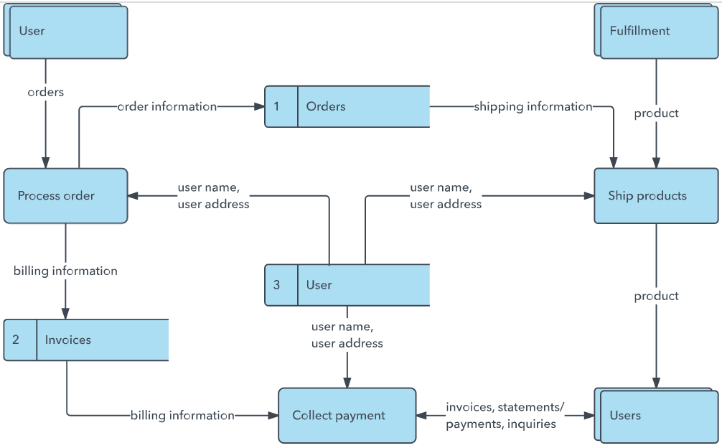


User Stories
Use the below template to list all the user stories for the product.
User Type | Functional Requirement (Epic) | User Story Number | User Story / Task | Acceptance criteria | Priority | Release
Sprint-1 | Location Search | USN-1 | As a user, I can find weather for a city or coordinates. | 3 | High | API / Frontend
Sprint-1 | Current Weather | USN-2 | As a user, I can retrieve current conditions through the API. | 5 | High | Backend / API
Sprint-2 | Forecasts and Alerts | USN-3 | As a user, I can retrieve hourly/daily forecasts and severe-weather alerts. | 5 | High | API Integration
Sprint-2 | AI Weather Summary | USN-4 | As a user, I can receive an AI explanation of forecast changes and risks. | 5 | Medium | AI Integration
Sprint-2 | Reliability and Security | USN-5 | As a user, I can use the API with secure access and clear error handling. | 3 | High | Backend / QA
 | Dashboard
Customer (Web user)
Customer Care Executive
Administrator

